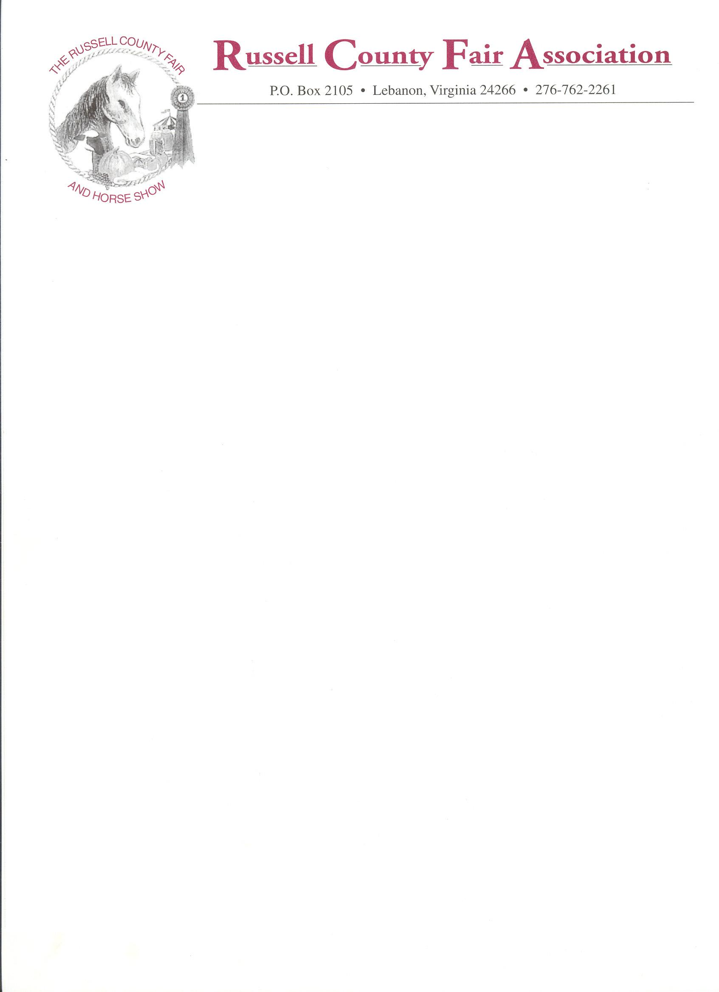

2026
COMMERCIAL SPACE APPLICATION (Sept. 4th-12th, 2026)

DATE________________
ORGANIZATION_____________________________________________________________
CONTACT PERSON___________________________________________________________
EMAIL ADDRESS ____________________________________________________________
Address______________________________________________________________________
Phone _______________________________________________________________________
Type of business or service offered (full description, please) _____________________________
___Food Concession ______$1,250 ___$950 non-profit, ___$250 Drink Vendors or ___Non- Food Space Required

FOOD VENDORS: All paperwork must be turned into the Health Department 10 days before the event in order to set up.
If the Health Department doesn’t have this information the vendor will be asked to leave the premises when they inspect.

Food Vendor prices are per week! They will not be pro-rated per days of attendance.

_____Outside (must be self-contained) ________10’x10’ ($150) ________10’x20’ ($275)
_____Non-profit (charitable) ($100) TAX ID__________________________________
Electrical hook-up _______Yes _________No #Amps _________110 ___________220
______$1,000,000 general liability proof of insurance must be included with application
Check applicable: _____________Display only _____________Cash Sales
Applicant agrees and understands by signing that this application is for space ONLY and is not a contract with the Russell
County Fair Association, Inc. The applicant also agrees and understands that the Russell County Fair Association, Inc., is
sole administrator of the rules governing the Fairgrounds, and agrees by signing this application to abide by rules as set forth by the Association.
SIGNED APPLICANT________________________________________TITLE_______________
Check No. ____________________attached in the amount of $____________________________
Remittance by Cashier’s Check or Money Order- No personal checks will be accepted.
Payments must be received 1 week prior to fair set-up. No refunds on cancellations. Make check payable to Russell County Fair Association, Inc., and mail to Angie Gibson at the address below.

ANGIE GIBSON, CHAIRMAN
CONCESSIONS & OUTSIDE VENDORS
2638 FLATS CIRCLE
CASTLEWOOD, VA 24224
276-202-2407

2 Exhibitor passes per booth space, or (2) one-day passes per day if different people will be working the booth. Passes will be given at setup Sunday, if booth space rental fee has been paid. NO EXCEPTIONS!
Additional passes may be purchased at the Fair Office. Set up for booths in main Commercial Exhibits Building is either Friday, Sept. 4th^{h} before noon or Sunday, Sept. 6th... NO PETS allowed on grounds, with the exception of service dogs; and for PET SHOW only. All pets are to be contained or leashed. Adopted pets are to remain with the agency or removed from the grounds at the time of adoption.

