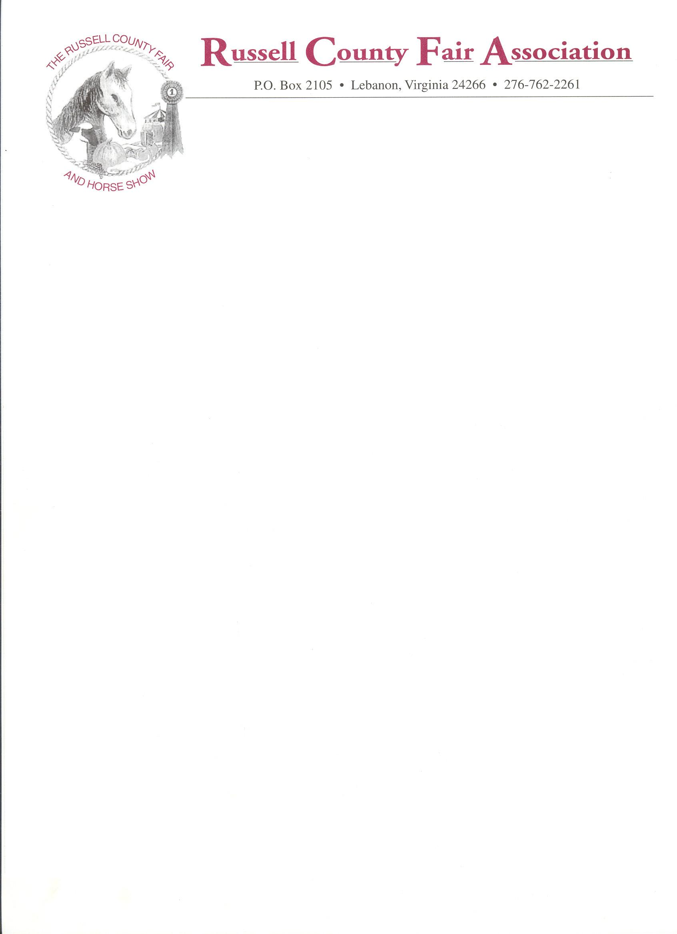

2026
COMMERCIAL SPACE APPLICATION (Sept. 4th-12th)

DATE________________
ORGANIZATION_____________________________________________________________
CONTACT PERSON___________________________________________________________
EMAIL ADDRESS ____________________________________________________________
Address______________________________________________________________________
Phone (day) ________________________ (cell) _____________
Type of business or service offered (full description, please) _____________________________
_____Inside _________8’x10’ ($175) _________8’x20’ ($300)
_____Non-profit (charitable) ($100) TAX ID__________________________________
If you are unable to commit to an entire week and would like a pro-rated amount based on days available,
Please note that your location may be altered. Weekly vendors have first choice of location.

Applicant agrees and understands by signing that this application is for space ONLY and is not a contract with the Russell
County Fair Association, Inc. The applicant also agrees and understands that the Russell County Fair Association, Inc., is
sole administrator of the rules governing the Fairgrounds, and agrees by signing this application to abide by rules as set forth by the Association.
SIGNED APPLICANT________________________________________TITLE_______________
Check No. ____________________attached in the amount of $____________________________
Remittance by Cashier’s Check or Money Order- No personal checks will be accepted.
Payments must be received 1 week prior to fair set-up. No refunds on cancellations .Make check payable to Russell County Fair Association, Inc., and mail to Darlene Austin at the address below.

DARLENE AUSTIN, CHAIRMAN
INSIDE COMMERCIAL EXHIBITS
34 Miracle Lane
Castlewood, VA 24224
276-701-1612

2 Exhibitor passes per booth space, or (2) one-day passes per day if different people will be working the booth. Passes will be given at setup Sunday, if booth space rental fee has been paid. NO EXCEPTIONS!
Additional passes may be purchased at the Fair Office. Set up for booths in main Commercial Exhibits Building is either Friday, Sept.4th before noon or Sunday, Sept. 6th.. NO PETS allowed on grounds, with the exception of service dogs; and for PET SHOW only. All pets are to be contained or leashed. Adopted pets are to remain with the agency or removed from the grounds at the time of adoption.

